**Introduction:**

The data provided for analysis contains details such as school types, school names, grades, maths scores, reading scores, budgets. The average scores were computed and the passing rates for both maths and reading were calculated based on grades greater than or equal to 70.

The table shows a summary of the data provided:

**Analysis:**

1. Performance of School

The graph above shows the results of the analysis for each school as per the percentage overall passing. Cabrera High School had the highest overall passing with 91.33% rate while Rodriguez High School had the lowest overall passing rate with 52.99%.

1. Scores by Grades

The performance of students both in Maths and Reading from grade 9 to 12 does not vary much for a particular school. This means that each school maintains almost a consistent performance in Maths and Reading across grade 9 to 12. Cabrera and Pena High Schools have achieved high maths, reading scores and overall, their averages are slightly higher compared to other schools. However, Figueroa and Ford High School have to work on their Maths and Reading scores as they have the overall lowest average scores across all grades.

The table below shows the analysis for maths and reading scores across grades 9 to 12.

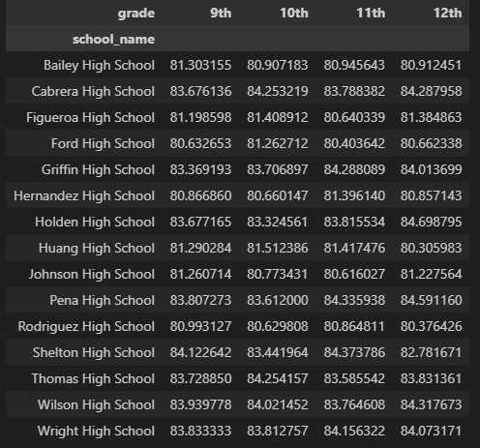Maths scores Reading Scores

**Conclusions**

1. Scores by School Spending

|  |  |  |  |  |  |
| --- | --- | --- | --- | --- | --- |
| **Spending Ranges (Per Student)** | **Average Math Score** | **Average Reading Score** | **% Passing Math** | **% Passing Reading** | **% Overall Passing** |
| <$585 | 83.46 | 83.93 | 93.46 | 96.61 | 90.37 |
| $585-630 | 81.9 | 83.16 | 87.13 | 92.72 | 81.42 |
| $630-645 | 78.52 | 81.62 | 73.48 | 84.39 | 62.86 |
| $645-680 | 77 | 81.03 | 66.16 | 81.13 | 53.53 |

**There is an inverse relationship between the spending ranges per student and academic performance**. The performance is based on the average scores in Maths, Reading and passing rates in both subjects as well as overall passing rate. This result show that spending less per student lead to higher scores and passing rates. Hence, we can advise schools that spending more does not guarantee high passing rates as other factors can affect the passing rates like teaching quality and students’ ability to learn.

1. Scores by School Spending

|  |  |  |  |  |  |
| --- | --- | --- | --- | --- | --- |
| **School Size** | **Average Math Score** | **Average Reading Score** | **% Passing Math** | **% Passing Reading** | **% Overall Passing** |
| **Small (<1000)** | 83.82 | 83.93 | 93.55 | 96.1 | 89.88 |
| **Medium (1000-2000)** | 83.37 | 83.86 | 93.6 | 96.79 | 90.62 |
| **Large (2000-5000)** | 77.75 | 81.34 | 69.96 | 82.77 | 58.29 |

The graph indicates that both small and medium schools have high achieving results but medium schools have slightly higher overall passing rate than small schools. From the scores by school size data, **we can conclude that small and medium schools perform significantly better than large schools.** The drastic decline could be due many students in a class and hence less attention to individual students, hindering overall performance of the class.

|  |  |  |  |  |  |
| --- | --- | --- | --- | --- | --- |
| **School Type** | **Average Math Score** | **Average Reading Score** | **% Passing Math** | **% Passing Reading** | **% Overall Passing** |
| **Charter** | 83.47 | 83.9 | 93.62 | 96.59 | 90.43 |
| **District** | 76.96 | 80.97 | 66.55 | 80.8 | 53.67 |

From the graph above and the school type data, **Charter schools perform better in Maths, Reading and have higher passing rates than District schools.** The reading scores for Charter is slightly greater than District Schools. However, there is a drastic decline for Maths passing rates and overall passing rates for District Schools.